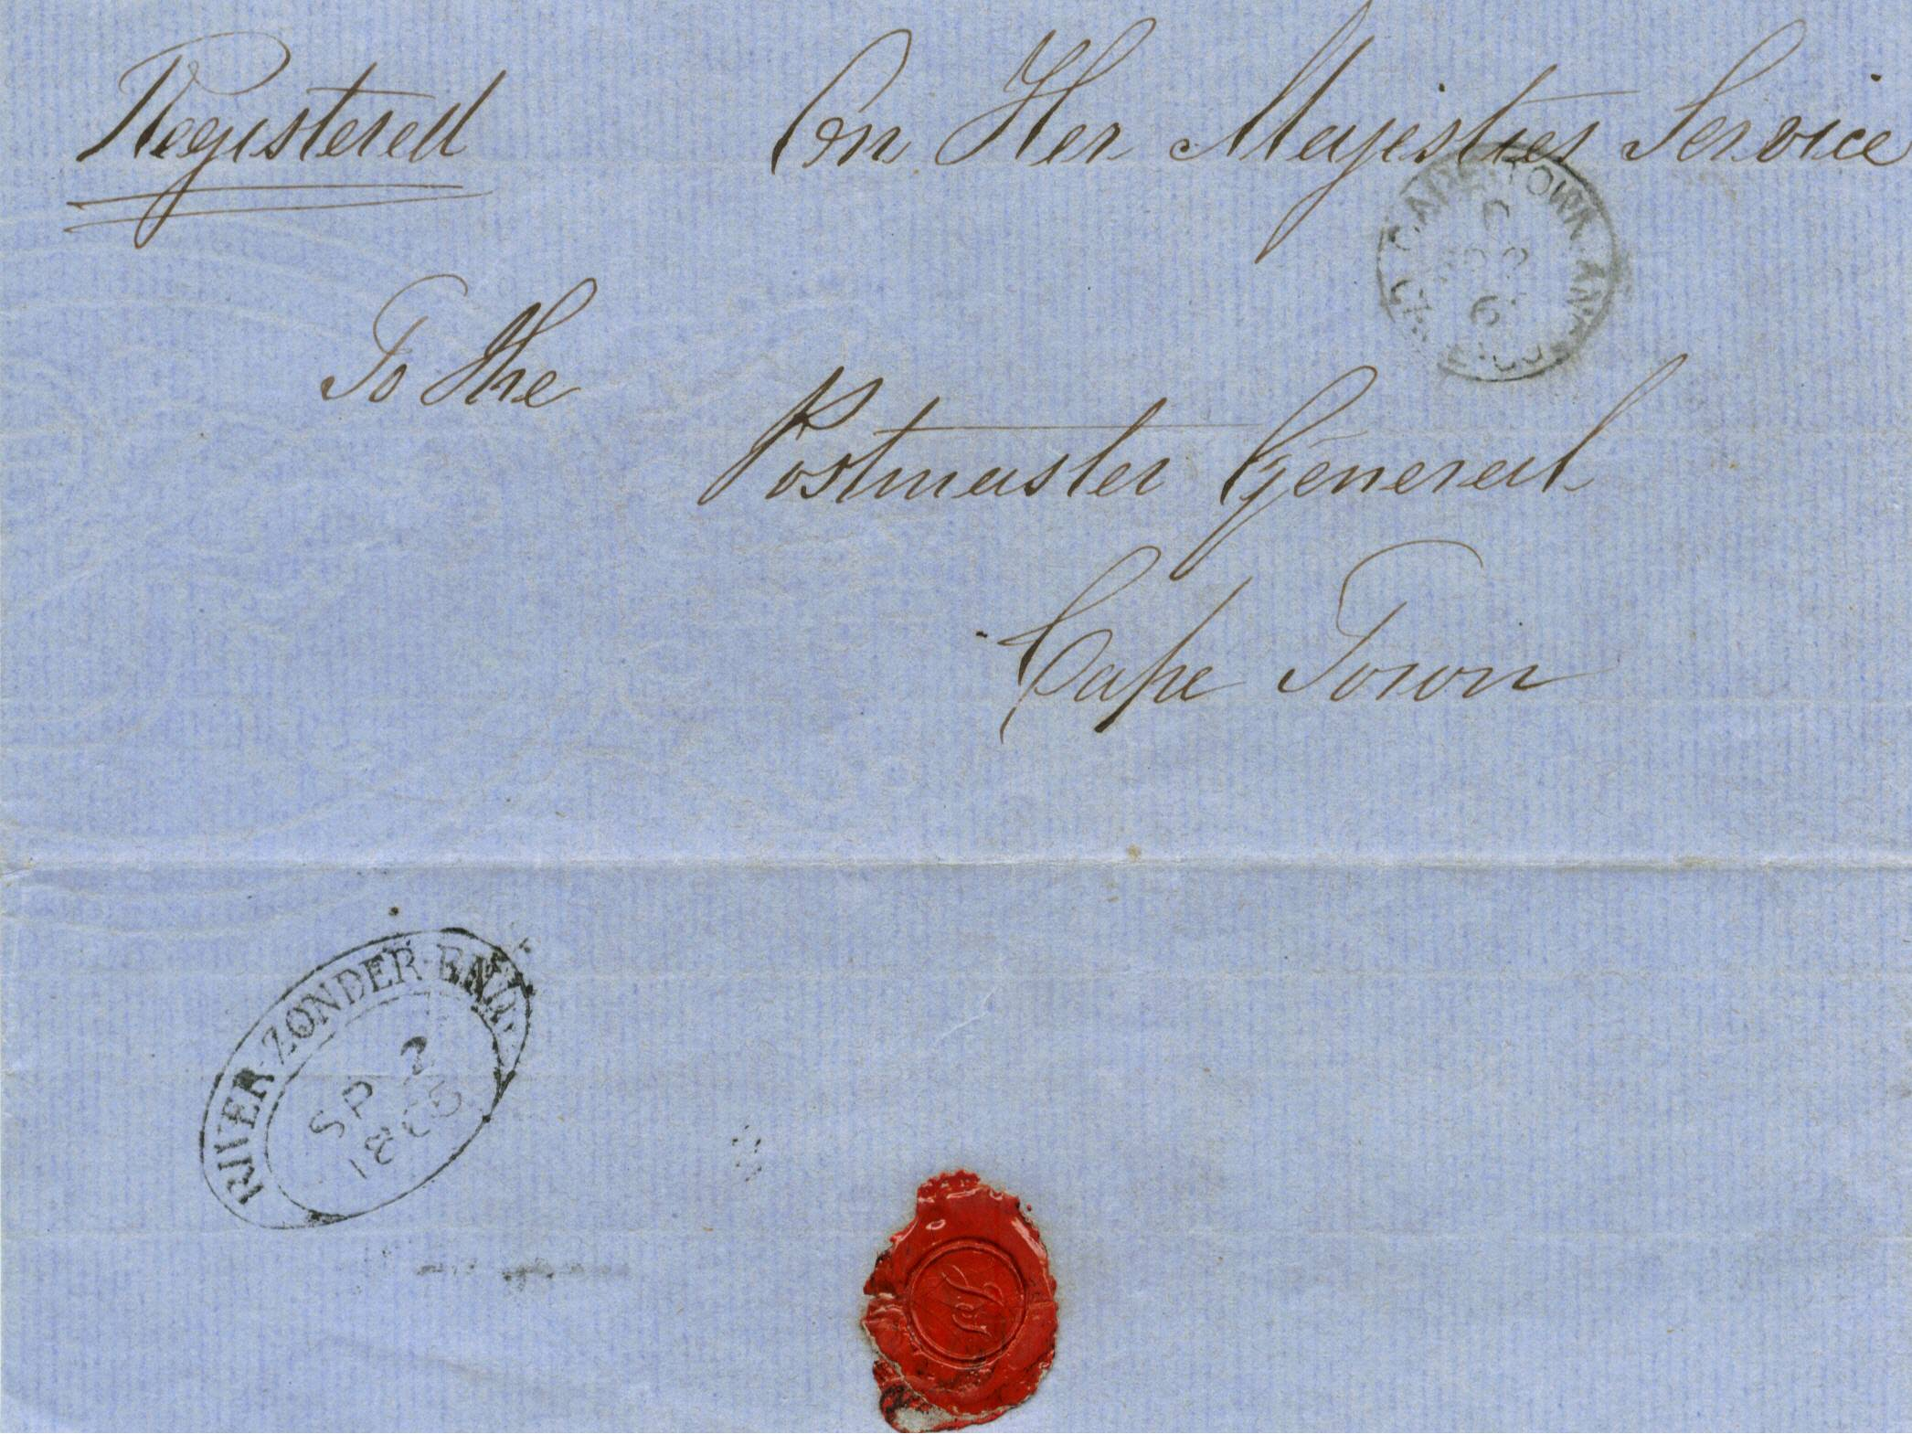
+

RIVER ZONDER END TOWN OVAL HANDSTAMP

1865 on H M Service pale blue outer letter sheet, from the River-zonder-end post office, showing a fine black strike of the “River-zonder-end D.T.O.” of 2nd September 1865. Cape Town receiving cds on front dated 2nd September 1965.

CAPE OF GOOD HOPE

DEVELOPENT OF POSTAL SERVICES

The Dated Town Oval

Handstamps of 1853

